**SY202 – Cyber Systems Engineering**

**Intro**

**CSE**

**Due Date: 12 Feb 2019**

**LABORATORY INVESTIGATION #03: Cyber Physical Systems Response**

**Objectives:**

1. To observe the time response (e.g., stability, settling time, and percentage of overshoot) of different first and second order systems.
2. To study how the location of the poles affects the time response.
3. To evaluate the effect that system properties such as damping and natural frequency have on the time response.

**Procedure**:

Note: During the exercise keep in mind that if you are confused about a MATLAB command you can type ‘help’ or ‘doc’ followed by the name of the function you’d like to know more about. *Google is also an extremely helpful reference.*

**Part I - Theory**

1. Finish Problems 3 and 4 from Homework #03 if you have not. You will use the solution in this lab exercise.
2. Consider the transfer function from Problem 4 in Homework #03:

|  |  |  |
| --- | --- | --- |
|  | $$G\left(s\right)=\frac{ω_{n}^{2}}{s^{2}+2ζω_{n}s+ω_{n}^{2}}=\frac{25}{s^{2}+4s+25}$$ | (1) |

where $ω_{n}=5$ and $ζ=$ 0.4. The location of the poles can be expressed in terms of the real and complex parts:

|  |  |  |
| --- | --- | --- |
|  | $$s_{1}=-σ_{d}+jω_{d}, s_{2}=-σ_{d}-jω_{d}$$ | (2) |

where $σ_{d}=ζω_{n}$ is the magnitude of the real part, $ω_{d}=ω_{n}\sqrt{1-ζ^{2}}$ is the magnitude of the complex part, $j$ is the imaginary number. For the system in equation (1), we have that $σ_{d}=2.00$ and $ω_{d}=4.58.$ Now, we will evaluate (i.e., approximate) the time response of the second order system in equation (1) as a function of $ω_{n}, ζ, σ_{d}, and ω_{d}.$ Use the formulas given in class. Follow the instructions below and fill out the Table 1.

**Case 0**: Problem 4 from Homework 03.

**Case 1**: Compute $σ_{d}, ω_{d}, T_{p}, T_{s}, \%OS$ when you increase $ω_{n}=10$, while keeping $ζ$ = 0.4.

**Case 2**: Compute $σ_{d}, ω_{d}, T_{p}, T_{s}, \%OS$ when you decrease $ω_{n}=2$, while keeping $ζ$ = 0.4.

**Case 3**: Compute $σ_{d}, ω_{d}, T_{p}, T_{s}, \%OS$ when you increase $ζ=0.7$, while keeping $ω_{n}=5$.

**Case 4**: Compute $σ_{d}, ω_{d}, T_{p}, T_{s}, \%OS$ when you decrease $ζ=0.1$, while keeping $ω_{n}=5$.

**Case 5**: Compute $ζ, ω_{n}, T_{p}, T_{s}, \%OS$ when you increase $σ_{d}=4.00$, while keeping $ω_{d}=4.58$.

**Case 6**: Compute $ζ, ω_{n}, T_{p}, T_{s}, \%OS$ when you decrease $σ_{d}=1.00$, while keeping $ω_{d}=4.58$.

**Case 7**: Compute $ζ, ω_{n}, T_{p}, T_{s}, \%OS$ when you increase $ω_{d}=8.00$, while keeping $σ_{d}=2.00$.

**Case 8**: Compute $ζ, ω_{n}, T_{p}, T_{s}, \%OS$ when you decrease $ω_{d}=2.00$, while keeping $σ_{d}=2.00$.

Table 1: List of Parameters for Second Order Transfer Function

|  |  |  |  |  |  |  |  |
| --- | --- | --- | --- | --- | --- | --- | --- |
| **Case #** | $ω_{n}$**(rad/sec)** | $$ζ$$ | $$σ_{d}$$ | $ω_{d}$**(rad/sec)** | $T_{p}$**(sec)** | $T_{s}$**(sec)** | $$\%OS$$ |
| **0**  **(Prob. 4a)** |  |  |  |  |  |  |  |
| **1** | 10 | 0.4 |  |  |  |  |  |
| **2** | 2 | 0.4 |  |  |  |  |  |
| **3** | 5 | 0.7 |  |  |  |  |  |
| **4** | 5 | 0.1 |  |  |  |  |  |
| **5** |  |  | 4.00 | 4.58 |  |  |  |
| **6** |  |  | 1.00 | 4.58 |  |  |  |
| **7** |  |  | 2.00 | 8.00 |  |  |  |
| **8** |  |  | 2.00 | 2.00 |  |  |  |

1. Check with your instructor before proceeding to next part.

**Part II – Simulation**

1. Create a new working folder for this lab and make sure to set this folder as your current directory in MATLAB. Copy the MATLAB script template *Lab3Script_template.m* available from the GAfG drive. Do not run the script yet, it is a template that you will need to modify.
2. Open a new Simulink model and save it as *Lab3Sim.slx*. Create the Simulink model illustrated below (refer to the previous lab or use the search option in the Simulink library to locate each block).

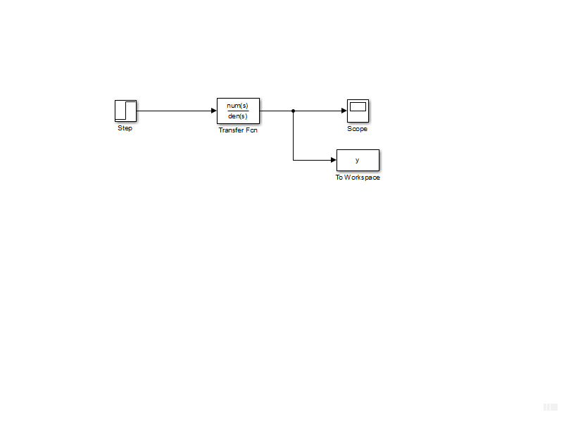

Figure 1. Simulink Model

1. Open the Step block. Set the *Step Time* to 0, the *Initial Value* to 0, and the *Final Value* to 1. This would create a step input. The *step time* indicates when (in seconds) the step function jumps from the *initial value* 0 to the *final value* 1.
2. Open the transfer function block. Set the numerator coefficients to *num* and denominator coefficient to *den*. “num” and “den” are two MATLAB variables that you will later create and modify from the MATLAB script. It is always a good programming practice to set parameters in the Simulink Model as variables (such as *num* and *den*) that you can later easily modify from a MATLAB script.
3. Open the scope block. We will use the scope for a quick visualization of the system response. Click on the “gear icon” at the top of the scope window. Select the Logging tab and uncheck the *Limit data points to last* if it was originally checked. Unchecking the latter option will tell Simulink not to truncate the data whenever it exceeds the 5000 samples.
4. Open the To Workspace block. Assign a *Variable name* to the output, e.g., “y”, and set the *Save Format* to *Array*.
5. Click on the gear icon at the top menu of your Simulink model or go to Simulation => *Model Configuration Parameters* in the top menu. Select *Solver* from the left menu and set *Stop time* to “tfinal”. “tfinal” will be a variable in your MATLAB script to specify and adjust the final time of your simulation. Set the *Max Step Size* to 0.05. From the same menu to the left, select *Data Import/Export*. Make sure that the *Limit data points to last* parameter is unchecked. You may need to click in *Additional Parameters* if the option does not show. Unchecking *Limit data points to last* will guarantee that the time of the simulation is saved correctly to your workspace. Most likely, the option was already unchecked by default.
6. Open *Lab3Script_template.m.* Note that the script is divided in sections that you need to complete. Follow the instruction in the script. Start with the first order system. Simulate the first order system from the Homework #03, Problem 3.

Note: After each simulation or case, make sure to save the time (“tout”) and the output inside the To Workspace block (“y”) into new variables. Be descriptive. For example, for the first simulation case you can type the following after running the simulation:

t_FO_case1 = tout; %FO = First Order; case1 = first example

y_FO_case1 = y;

1. Open the scope in your Simulink model and measure the settling time for each case.
2. Fill out the following table:

Table 1. First Order System Results

|  |  |  |  |
| --- | --- | --- | --- |
| **Case: $G\left(s\right)=\frac{a}{s+a}$** | **Theoretical Approximation $T_{s}$ (sec)**  **(Using Formula)** | **Simulation $T_{s}$ (sec)** | $\%$**of Difference** |
| $$a=1$$ |  |  |  |
| $$a=2$$ |  |  |  |
| $$a=3$$ |  |  |  |
| $$a=4$$ |  |  |  |

$$\% Diff=\left|\frac{TheoApproxValue-SimValue}{\left(\frac{TheoApproxValue+SimValue}{2}\right)}\right|×100$$

1. Overlay the four responses in a single plot. Do not forget labels, different line styles, and legend, among other professional practices.
2. Discuss the effect that pole location has on the settling time. Discuss any discrepancies between your calculated and simulated values.
3. Simulate the second order systems from Part I of this document (cases 0 through 8 in Table 1).
4. To compute the settling time, peak time, and percentage of overshoot, you can use the command:

stepinfo(y,t,yfinal)

where “y” is the name of your output variable, “t” is the end of the time vector, and “yfinal” is the last value of your output array. You may use the help command to find more info about stepinfo(). Depending on how you named your variables, you can use something like:

stepinfo(y_FO_case1, t_FO_case1, y_FO_case1(end))

The end command in the last array returns the last element of the array.

1. If there is a large discrepancy between the values estimated in Table 1 with those obtained in the simulation, try using the scope to measure the settling time, peak time, and %OS. In some rare occasions, the stepinfo command may fail to yield accurate results.
2. Fill out the following table, where Theo are the theoretical approximations from Table 1:

Table 2. Second Order System Results

|  |  |  |  |  |  |  |  |  |  |
| --- | --- | --- | --- | --- | --- | --- | --- | --- | --- |
| **Case #** | $T_{s}$**(sec)** | | | $T_{p}$**(sec)** | | | $$\% OS$$ | | |
| **Theo** | **Sim** | **% Diff** | **Theo** | **Sim** | **% Diff** | **Theo** | **Sim** | **% Diff** |
| **0** |  |  |  |  |  |  |  |  |  |
| **1** |  |  |  |  |  |  |  |  |  |
| **2** |  |  |  |  |  |  |  |  |  |
| **3** |  |  |  |  |  |  |  |  |  |
| **4** |  |  |  |  |  |  |  |  |  |
| **5** |  |  |  |  |  |  |  |  |  |
| **6** |  |  |  |  |  |  |  |  |  |
| **7** |  |  |  |  |  |  |  |  |  |
| **8** |  |  |  |  |  |  |  |  |  |

1. Create a subplot of two figures. Use:

subplot(1,2,1)

plot(t_SO_case0, y_SO_case0, …

subplot(1,2,2)

plot(t_SO_case5, y_SO_case5, …

In the first subplot, plot cases 0 to 4. In the second subplot, overlay the response of cases 5 to 8.

1. Discuss the effect that pole location and different system parameters have on the settling time, peak time, and overshoot. Discuss any discrepancies between your calculated and simulated values.

**Lab Report:** Follow the lab report template and the general lab guidelines for SY202 lab reports. Refer to the lab rubric for the grading of the lab.